New section of Roman Town Wall discovered in Gloucester

Archaeological investigations are currently being carried out by Cotswold Archaeology during the development of land to the south-east of Gloucester Prison by Midas Construction Ltd for Cityheart Ltd, in preparation for the construction of student accommodation. From 1898, the site was the location of Gloucester Electricity Works. During the removal of massive foundations associated with one of the power station’s chimneys, part of the western wall of Roman Gloucester was revealed for the first time since its demolition, over 900 years ago.

In AD 49, shortly after the Roman invasion of Britain and during the start of the conquest of the area that is now Wales, a legionary fortress was established at Kingsholm in Gloucester. This fortress was abandoned in around AD 66-67, and a new fortress was established at the site of the modern city centre, with walls built of timber and earth. By the end of the 1st century AD, this fortress was abandoned by the Roman army and became the heart of a new colonia, a settlement for retired veterans called Glevum.

Later during the 2nd century AD, the defences of the growing town were rebuilt in stone. The line of the Roman town walls has been identified in many developments within the city over the past 60 years. The east wall of the Roman town runs along Brunswick Road and under the Museum of Gloucester, where the east gate of the Roman and Medieval town can be seen through a glass window, in the street next to Boots on Eastgate Street. Kings Square is in the north-eastern corner of the town and a corner wall tower was recently uncovered during the redevelopment of the square, between Subways and the Regal Pub. The southern wall of the town would have run along Parliament Street and Commercial Road. The western wall, which separated the Roman town from its harbour on the banks of the River Severn, ran from the sub-station behind the Gloucester Academy of Music to under the old fire station.

However, the exact location of the west wall lay largely hidden until now. Only the lowest part of the wall foundation survives and consists of very large blocks of limestone, which would have been placed on the top of wooden piles and driven into the soft ground to stabilise it. The lowest courses of the wall were un-mortared to provide a robust, but flexible foundation for the main wall. If the west wall was like the rest of the town wall, the earthen bank or rampart of the old legionary fortress would have been retained and enhanced on the inside of the wall, with a large ditch to the exterior.

The west wall was demolished at some point before a Norman castle motte - essentially a large mound of earth with a fortified timber tower on top - was constructed over the Roman town wall and ditch, overlooking Gloucester’s harbour. When the Roman wall was demolished, many of its stones were salvaged for reuse in other medieval buildings, but unwanted rubble was left behind and used with earth from the demolished rampart to fill in the ditch and bury the remains of the wall.

Cotswold Archaeology Project Supervisor Buzz Busby adds "as an archaeologist, finding something lost from the past is always exciting, especially when we can tell its story and change the way we view the streets we walk."

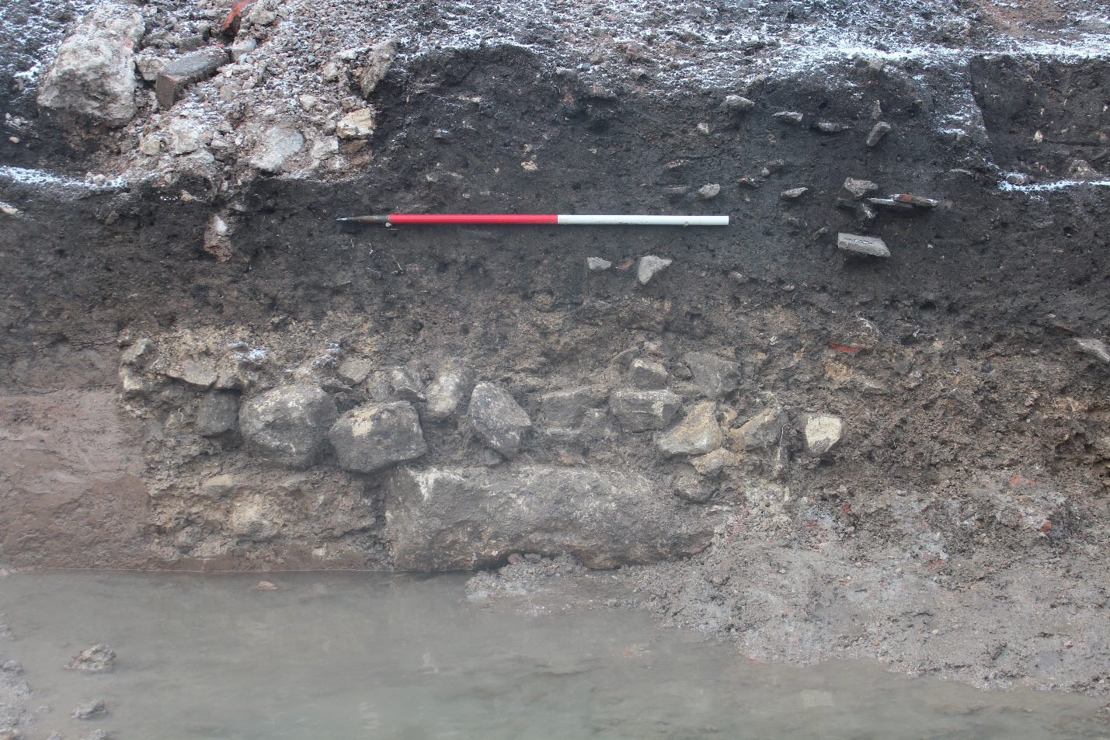
The western Roman town wall exposed by the removal of the Victorian chimney foundation

